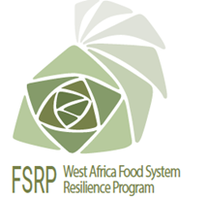
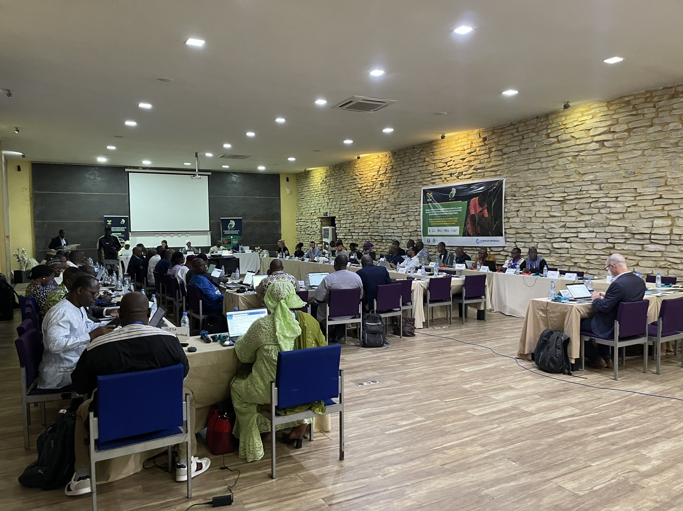
PRESS RELEASE
Second wrap up meeting of the FSRP implementation support missions: countries and regional institutions shared their results and experiences
From 16 to 19 May 2023 in Saly Portudal, Senegal, stakeholders and partners of the West Africa Food System Resilience Program (FSRP) met for the second wrap up meeting of the support missions to the implementation of the program.
In the run-up to this wrap up meeting, the World Bank and its partners conducted missions to each coordination unit of the regional institutions (RAAF/ECOWAS, CILSS/Agrhymet, and CORAF) and the 7 countries (Burkina Faso, Mali, Niger, Togo, Ghana, Sierra Leone and Chad).

During these missions, stakeholders and partners reviewed the recommendations made during the previous missions held in November and December 2022; examined the activities carried out within the framework of the 2023 work plan and budget (WPB); evaluated the measures taken to respect the implementation of environmental and social safeguards; reviewed financial management, procurement and the results framework.
These missions were followed by a wrap-up meeting to consolidate achievements and find solutions to common challenges.

During the 5 days of exchange, the main results achieved, lessons learned and challenges were shared in relation to: (i) development of digital advisory services for the prevention and management of agricultural and food crises, (ii) strengthening the sustainability and adaptability of the productive base of the food system and (iii) development of regional integration in order to strengthen synergies between implementing actors.

Specific technical meetings were held between the heads of the national and regional centres of specialisation, between specialists in charge of environmental safeguard and social development issues. Monitoring and evaluation specialists and coordinators met to agree on appropriate mechanisms and approaches to monitor and document all FSRP results and experiences.

The second wrap up meeting of the support missions identified the needs of the countries at the institutional and technical levels in order to better coordinate the support of regional institutions; the national and regional actors were invited to increase their collaboration and cooperation in order to meet the challenges and accelerate the implementation of activities for the benefit of the various beneficiaries. They welcomed the assumption of duties by the regional team at the level of the RAAF/ECOWAS in order to truly ensure the overall coordination of the FSRP, which involves several actors and partners at all levels. The FSRP monitoring and evaluation manual was approved by all the participants.
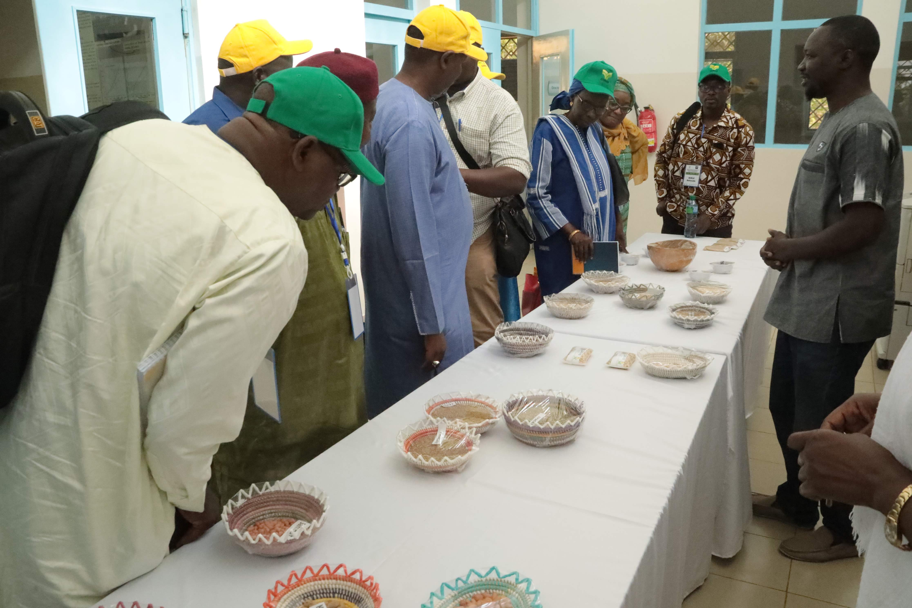In addition to the indoor sessions, a field visit was organized to discover the know-how of the Centre d'étude régional pour l'amélioration de l'adaptation à la sécheresse (CERAAS), located in the region of Thiès, an ECOWAS regional centre of excellence on dry cereals which is part of the FSRP's facility for innovations and technologies related to climate-smart agriculture. It has technologies that the FSRP can scale up in integrated landscape management.

The stakeholders and partners of the FSRP will meet from 23 to 27 October 2023 in Niamey for the third wrap up meeting of the support missions organized by CILSS/Agrhymet and the National Coordination of the FSRP Niger

---------------END-----------------
For further information, Kindly contact:
Communication Unit, RAAF
Telephone: +228 22 21 40 03 - Email: fdabire@araa.org CC ykone@araa.org
Twitter: ARAA_CEDEAO - Facebook: araaraaf
www.araa.org

